Michael Weaver

CST – 235

Brandon Bass

1/17/17

**Short Assignment 6**

GitHub Link: <https://github.com/battousairurik/CST-235>

**Assignment Approach**

For this assignment I spent a good 6 hours trying to research ho to approach it and wound up with very little information to go on. I wound up creating two different portions of the project, but could not combine them for an actual CRCW application. The first portion is a logging servlet that is supposed to log input on the server’s log (in this case WildFly) though I could not figure out how to access the log or create a log file that would work. The second portion is an attempt to create the read portion of the program which utilizes an xhtml page and a few filters, though it too does not have full functionality.

At one point I attempted to move the files from one folder to another and lost all of them, then had to rebuild them from the local memory, and even then, the bulk of the class was lost so they had to be rebuilt from scratch. It was something that really confused me.

**List of Classes, Methods, Variables, etc.**

LoggingServlet.java (with init, doFilter, ReadFile methods), FilterServletOutputStream.java, GenericResponseWrapper.java, MYGenericFilter.java, PrePostFilter.java

**Screenshots**

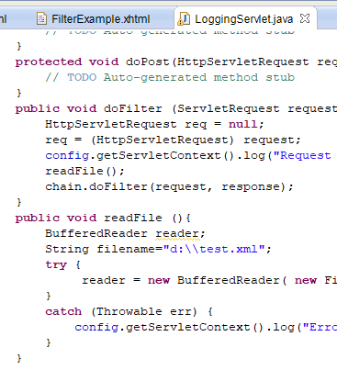

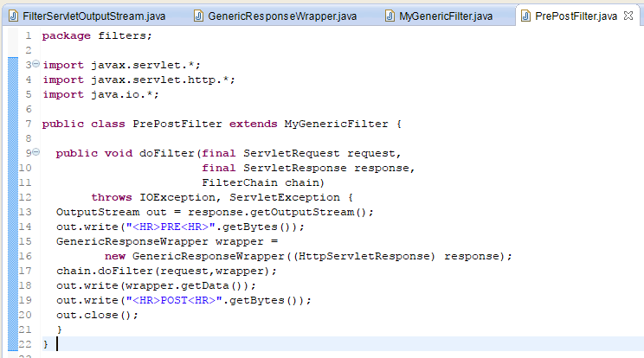

References

Oracle. (2017). *Servlet Filters and Event Listeners*. Retrieved from <https://docs.oracle.com/cd/B14099_19/web.1012/b14017/filters.htm>